**Code Smells:**

Code smell 1: Array designators "[]" should be on the type, not the variable

Code:

Location: src/main/java/jabref/logic/remote/shared/listener/PostgresSQLNotificationListener.java

In this specific snippet, the array designator is located on the variable. For better code readability the array designators should always be located on the type. If not, maintainers will have to look at both the type and the variable name to decide if it is an array.

This code smell can easily be fixed by moving the array designator to the type.

Refactoring proposal:

Code smell 2: Asserts should not be used to check the parameters of a public method

Code:

Location: src/main/java/jabref/logic/remote/shared/prefs/SharedDatabasePreferences.java

In this specific snippet, there is an inappropriate use of an assertion since it was used for parameter validation. This can´t happen because assertions can be disabled at runtime therefore a bad operational setting would eliminate the intended checks. Also, it would be thrown an AsserionError which is very different from an Exception.

This code smell can easily be fixed by using some kind of exception rather than an assertion.

Refactoring proposal:

Code smell 3: Local variables should not be declared and then immediately returned or thrown

Code:

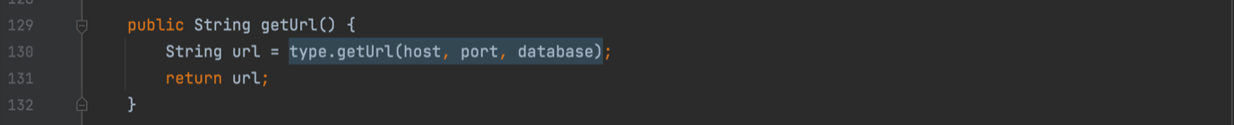

Location: src/main/java/jabref/logic/remote/shared/security/DBMSConnectionProperties.java

In this specific piece of code there is a common bad practice. Declaring a variable only to immediately return or throw it is useless.

This code smell can easily be fixed by returning the value of the local variable instead.

Refactoring proposal:

